Contact: Rick Scott 310.306.0375
rick@greatscottpr.com

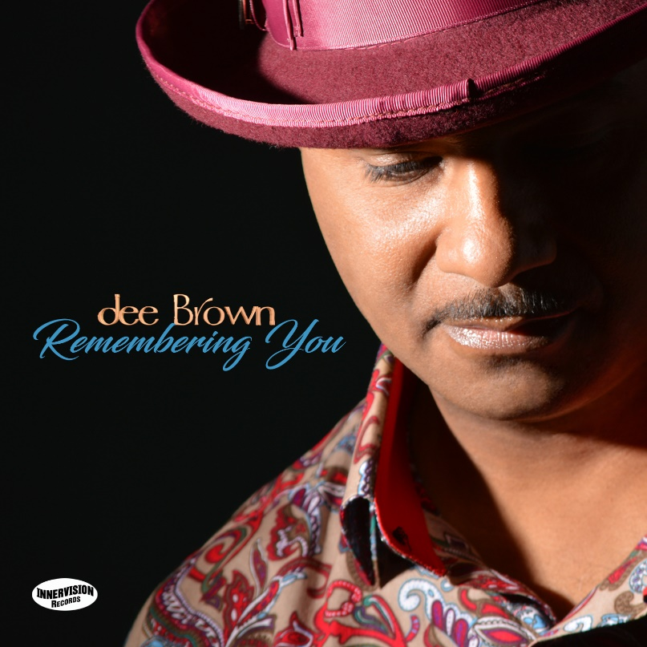

Urban-jazz guitarist dee Brown remembers his
late fiancée with songs of love and joy

His fourth album is a celebration of life chronicling their time together with fun and spirited songs such as the new chart-bound single, “Pop the Question.”

SOUTHFIELD (22 June 2018): Two years ago, soul-jazz guitarist dee Brown was preparing for a summer wedding to his fiancée, gospel singer Shaunia Edwards. When her young life was tragically cut short by an unexpected illness, he was devastated, leaning on his strong faith to endure. Shifting his mindset from a mourning period during which he sought meaning by asking “Why?” to a perspective of positivity, Brown turned to writing, honoring the sweet, lasting memories of Edwards and their romance by composing lively, intimate and playful stories of love, laughter and hope. He shares his fond remembrances via the ten new songs that constitute his fourth album, “Remembering You,” his second release for Innervision Records.

Determined to make “Remembering You” a joy-filled affair, Brown imparts his charming recollections by setting his lyrically expressive, loose and improvisational cool jazz fretwork amidst ebullient pop nuances, pulsating dance beats and sensual R&B grooves. He picks, plays and scats soulfully throughout, inspired to celebrate his season with Edwards by deriving meaning from her lingering place in his heart, not in the loss of her physical presence.

“Shaunia was the reality of my dreams, a woman heaven sent to make me whole. ‘Remembering You’ celebrates her life and our life together. It’s purposely an upbeat celebration, not a mourning. The meaning that I derived from this experience and a message I think everyone can relate to is that we should exalt those in our lives as well as remember those who are no longer in our lives for whatever reason. Tomorrow is coming, but not necessarily for you. Share our love with those with us in the here and now because tomorrow is not guaranteed,” said Brown, who coproduced nine of the album’s tracks.

A loving, encouraging greeting from Edwards opens “Hey Baby,” the sweeping, feel-good first single illuminated by fervent guitar and alto sax banter on the cut that presaged the set’s arrival. Brown’s frequent writing and producing partner, pianist-keyboardist-programmer Valdez Brantley (Usher’s former music director), uses the vocoder to tantalize and tease on “Pop the Question,” the current chart-bound single that appears on the record in both album and d-Funk remix versions. Other noteworthy contributions are made by keyboardist Bob Baldwin, who also produced and cowrote the sleek and sophisticated “I Will”; Althea Rene, who adds fanciful flute flourishes to the vibrant escapade “Our Summer”; and keyboardist Nate Harasim, cowriter and producer of the sultry reflection “Beauty Within.”

A Detroit born and based guitar man who got his start in music as a vocalist, Brown launched his solo career in 2007 with “No Time To Waste.” Teaming with Valdez and Kern Brantley (Lady Gaga’s former music director and bassist who plays on “Remembering You’s” opener, “I Want You Too”) two years later for his sophomore outing, “A Little Elbowroom,” proved formative to his sound and style. Brown dropped his first recording for Innervision Records in 2014, “Brown Sugar Honey-Coated Love,” spawning the Top 15 Groove Jazz Music chart single, “Natural Love.”

Brown performs regularly on the Motor City music scene backed by Valdez Brantley, saxophonist Dezie McCullers Jr. and drummer Ron Otis, his core band that appears on the new album. Brown is looking forward to performing cuts from “Remembering You” in a big setting at the River Raisin Jazz Festival on August 11held in nearby Monroe, Michigan. One week later, his summer wedding will finally take place when he takes marriage vows with “a beautiful child of God.”

Brown’s “Remembering You” album contains the following songs:

“I Want You Too”
“Hey Baby”
“Pop the Question”
“Our Summer”
“I Will”
“Follow You”
“So Much”
“Pop the Question” (d-Funk remix)
“Beauty Within”
“Remembering You”

For more information, please visit http://deebrownmusic.com.

# # #

